MODULE-1

What is an operating system

An operating system is an interface between user and computer hardware. It manages computer hardware it provides an environment to execute the application programs. The operating system is designed to be convenient and to be efficient.
Computer system is divided into
1. Hardware
2. Operating system
3. Application program
4. Users

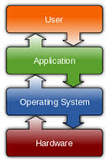
Fig:Operating system

End user employs the application program. Application programs uses the system software to produce an application program for end user and operating system programmers uses the hardware to implement system software.
Generally the operating system will manage to use the hardware by other system software and all application software. Because of this we say operating system is software that is implemented “closest to hardware”.

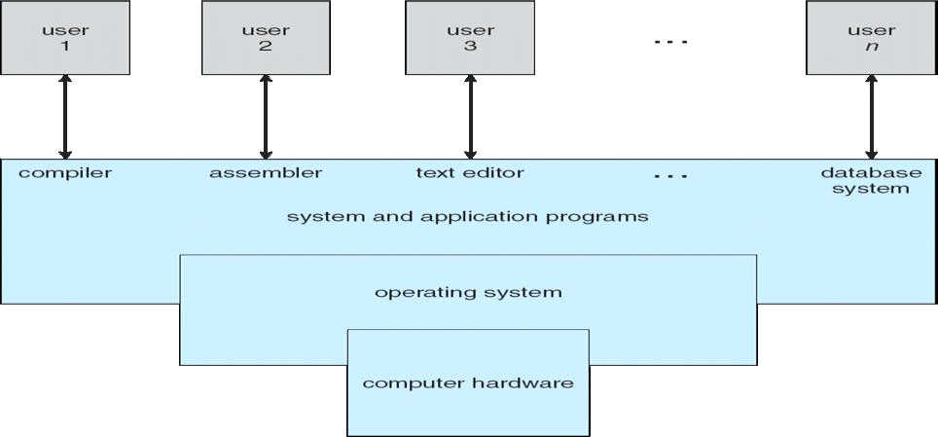
Fig: Abstract view of the components of a computer system

How operating system is different from other system software
1. Operating system directly interact with network, it is also a part of system software.
2. It manages peripheral devices
3. It looks after the memory management
4. It allocates resources
5. It looks the CPU not to sit idle.

The operating system is a creator as well as a coordinator. It holds the abstraction of all the functionalities of the system like process management, device management, file management, disk management etc.

Operating system can be viewed in two ways
a) User view
b) System view

a) User view
Most of the user sit in front of a pc and performs some task. Some users sit at a terminals connected to a mainframe or minicomputer and other user’s access through other terminals, these users can share resources and information. The operating system is designed to maximize resource utilisation other users sit at workstations connected to network of other workstations and servers.

b) System view
The operating system is the program that is most intimate with the hardware. We can view it as a resource allocator.

Types of operating system

1. Batch system
2. Multi-programmed system
3. Time sharing system
4. Multi-processor system
5. Distributed system
6. Real time system
1. Batch system
In early computers the user did not interact directly with the computer system, they used to prepare a job which consist of program, data and some control information and submitted to the computer operator. The job is usually in the form of punch cards. After some later time the output is appeared. These systems job is to transfer control automatically from one job to the next. The operating system also resides in the memory.

operating system
User program area

To speed up the process operators used to batch the jobs together will similar type of operations as a group, and the user used to leave these jobs to computer operator. The operator would sort programs into batches with similar requirements. The output is sent back to the appropriate programmer. In this type of system, the CPU is often idle.

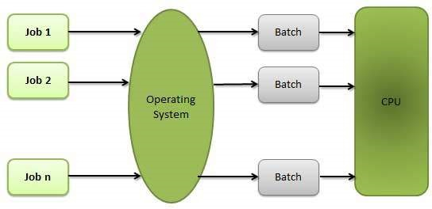

Fig:Batch processing system

2. Multi-programmed system
Multi-programmed increases CPU utilisation by organising jobs so that CPU always has one to execute. The operating system keeps several jobs in memory. The operating system picks and begins to execute one of the jobs in the memory. If this job wants to perform an I/O operations, the operating system picks another job and existing job has to wait. When the job in memory needs an I/O event them operating system switches to previous job and gets executed. In this system, the CPU never sit idle.

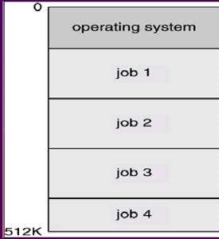

Fig:Multi-programmed system

3. Time sharing system
Multi-programmed batch system provided an environment where several resources are efficiently used but it did not provide user interactions with computer system. Time sharing (or multi-tasking) is an extension of multi programming. The CPU executes multiple jobs by switching among them and the user can interact with each program while it is running. The user gives instructions to operating system in the form of commands. A time sharing operating system allows many users to share the computer simultaneously. It uses CPU scheduling and multi programming to provide each user with a small portion of a time shared computer. This type of system is complex to design because it cannot keep several jobs in memory at a time, so with the help of virtual memory it performs the task.

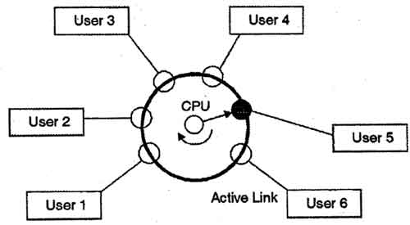

Fig:Time sharing system

4. Multi-processor system
Many of the systems are single processor systems i.e. they have only one CPU. In multi-processor system (or parallel system) have more than one processor in close communication sharing the resources of the system. The advantages of this system is
a) Increased throughput:
A number of program can be executed in multiprocessor system at a time by sharing the resource.

b) Economy of scale:
These systems can save memory the multiple single processor system, because of sharing mechanism.

c) Increased reliability:
If functions can be distributed among several processors if failure of one processor will not halt the system only slow it down, we can execute the function in other processor.

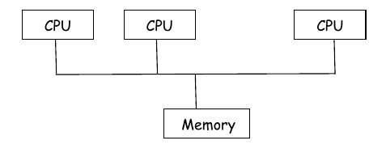
Fig:Multi processor system

5. Distributed system
It is a modern computer to interconnect groups of PC, batch systems time sharing and real time system. This has an influence on operating system strategies because of the need for strategy to handle resources and information sharing across the machines interconnected with a network.
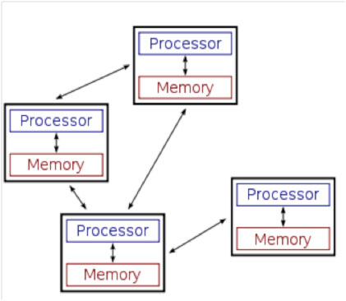

Fig:Distributed system

6. Real time system
A real time system is used when rigid time requirements have been placed on the operation of a processor on the flow of data then it is used as a control device in an application. Sensors bring data to the computer. It is a well-defined, fixed-time constraint. Processing must be done within the defined constraints, or the system will fail.

It is of two types 1. Hard real time system
2. Soft real time system

a) Hard real time system: - It guarantees that critical tasks can be completed on time.
b) Soft real time system: - In this a critical real-time task gets priority over other tasks and retains that priority until it completes.

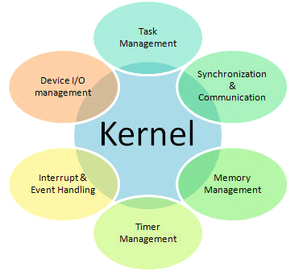

Fig:Real time system

Operating System Components

Operating System is a large and complex system so it is portioned into small pieces each perform its own task. When the user interacts with OS behalf of it, it performs the following functions.
1. Process Management.
2. Main-Memory Management
3. File-Management
4. I/O System Management
5. Secondary-Storage Management
6. Networking
7. Protection System
8. Command-Interpreter System

1. Process Management
A program is a set of instructions and a process is when a program under execution. A process needs certain resources like CPU time, memory, files and I/O devices to accomplish a task. These resources are allocated to a process when it is created or while it is running. After completion it, the OS will reclaim the resources.
The responsibilities of OS in connection with process Management.
- Creating and deleting both user and system processes.
- Suspending and resuming processes
- Providing mechanism for process synchronization, communication and deadlock handling.

2. Main-Memory Management
The OS is responsible for the following activities in connection with memory management.
- Keeping track of which parts of memory are currently being used and by whom.
- Deciding which processes are loaded into memory when memory space becomes available.
- Allocating and de allocating memory space as needed.

3. File Management
It is the most visible component of an OS. It stores info on different types of physical media.
The OS is responsible for the following activities
- Creating and deleting files and directories
- Supporting primitives for manipulating files and directories.
- Mapping files onto secondary storage
- Backing up files on stable storage media

4. I/O System Management
The I/O system consists of
- A memory-management component that include buffering, caching and spooling.
- A general device-driver interface
- Drivers for specific hardware devices.

5. Secondary-Storage Management
The main purpose of a system is to execute programs. The program with the data they access must be in main memory during execution. Because main memory is small to accommodate all data the system provides secondary storage to backup main memory.
The responsibility of OS in connection with disk management is
- Free space Management
- Storage allocation
- Disk Scheduling

6. Networking
A distributed system is a collection of processors that do not share memory, peripheral devices or a clock. The processors in the system are connected through a communication network.

7. Protection System
If a computer has multiple users and allows concurrent execution of multiple processes, then process must need protection from one another.
Protection is a mechanism for controlling the access of programs, processors or users to the resources defined by a system.

8. Command-Interpreter System
It is an interface between user and OS. Some OS include command-Interpreter in the Kernel, other OS like MS-DOS, UNIX treat it as a special program.

Operating System Services[p-i-c-r-a-p-e-f]

Oeraring System provides an environment for the execution of programs. To make the programming task easier, the OS provides services like,

1) Program Execution
The system must load program into memory and to run that program. This program must be able to end its execution either normally or abnormally.

2) I/O Operation
A running program may require I/O operation. This I/O may be a file or an I/O device. For efficiency and protection, users cannot control I/O devices directly. Therefore OS must provide a means to do I/O.

3) File System manipulations
Program need to read and write files. It also need to create and delete file by name.

4) Communications
In some cases, one process needs to exchange information with another process i.e., processes that are executing on different computer systems tied together by a computer network. Communications may be implemented via shared memory or through message passing, in which packets of information are moved between processes by the operating system.

5) Error Detection
The operating system needs to be constantly aware of possible errors. Errors may occur in the CPU and memory hardware (such as a memory error or a power failure), in I/O devices (such as a parity error on tape, a connection failure on a network, or lack of paper in the printer), and in the user program (such as an arithmetic overflow, an attempt to access an illegal memory location, or a too-great use of CPU time). For each type of error, the operating system should take the appropriate action to ensure correct and consistent computing.

6) Resource allocation
When there are multiple users or multiple jobs running at the same time, resources must be allocated to each of them. Many different types of resources are managed by the operating system.Some (such as CPU cycles, main memory, and file storage) may have special allocation code, whereas others (such as I/O devices) may have much more general request and release code.

7) Accounting
The OS should keep track of information like which users use how many and what type of resources.

8) Protection
The owners of information stored in a multiuser or networked computer system may want to control use of that information. Protection ensures that all access to system resources is controlled. Security ensures authentication by means of password.

System Calls

System Calls provide an interface between process and Soothes calls are generally available in assembly language instructions. UNIX system calls may be invoked directly routines written in C and C++ program

Three general methods are used to pass parameters to the operating system.
1) Pass the parameters in registers.
2) In some cases there may be more parameters then registers. In this case parameters are stored in a block or table in memory and the address of the block is passed a parameter in a register. It is used in the LINIUX
3) Some operating system uses the block or stock methods, this approach do not limit the number of length of parameters being passed.
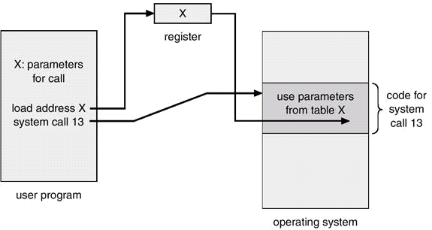

Fig:Passing of parameters as a table

System calls are grouped into five categories
1. Process control
2. File management
3. Device management
4. Information management
5. Communication
1. Process control
A running program need to halt its execution either normally or abnormally (abort).If a system call is made to terminate the running program abnormally, a dump of memory is taken and an error message is generated. The demo is written to disk and examined by a debugger to determine the cause of problem. The operating system must transfer the command to command interpreter.
- The command interpreter then reads next commands.
- In an interactive system command interpreter simple continues next command.
- In batch system, command interpreter terminates the entire job and continues with next job.

Process control system calls:
- End, Abort
- Load, Execute
- Create Process, terminate process
- Get process attributes, set process attributes
- wait for time
- wait event, signal event
- Allocate and free Memory
2) File Management
- Create, Delete Files
- Open, close
- read, write reposition
- get file attributes, set file attributes

3) Device Management
- Request Device, Release Device
- Read, write, reposition
- get device attributes, set device attributes
- Logically attach or detach devices

4) Information Maintenance
- Get time or date, set Time or date
- Get System Date, set System date
- Get process file or Set process file
- Get device attributes or Set device attributes
5) Communications
- Create, delete communication connection
- Send, Receive messages
- Transfer status information
- Attach or Detach remote devices

Fig: a) Message passing b) Shared memory

System Programs

System Programs provide a convince environment for program development and execution. They are divided into:
1. File Management: These programs create, delete, copy, rename, print, dump, list and generally manipulate files and directories.
2. Status information: It is a program that gives information about system date, time, amount of memory available, disk space, number of users etc. That information is formatted and is printed to the terminal or other output or file.
3. File modification:
Several text editors are available to create and modify the content of files stored on the disk or tape.
4. Programming Language Support:
Compilers, assemblers and interpreters are often provided to the user with the operating system.
5. Program loading and execution:
Once a program is assembled or compiled, it must be loaded into memory for execution. The system will provide absolute loader, re locatable loaders, linkage editors and overlay loaders.
6. Communications:
These programs provide a mechanism for connections among processes, users and different computer systems. They allow users to send messages to one another, to browse web pages, games, database system, word processor, send electronic mail messages, transfer of file from one machine to another.

System Structure

A system as large and complex as a modern operating system must be designed carefully to function properly. A common approach is to divide the system into small components and each module is well-defined portion of the system.

1. Simple structure:

MS-DOS is a simple small and limited system written to provide the most functionality in the least space because of limited hardware. It is not divided into modules.
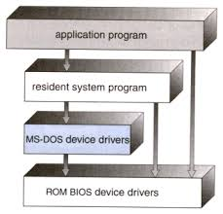
Fig:MS-DOS layer structure

Another example of limited structuring is the original UNIX operating system. Like MS-DOS, UNIX initially was limited· by hard ware ft1il.cfionali.ty. It consists of two parts
1. Kernel
2. System program
Kernel is further separated into a series of interfaces and device drivers. Below system call interface and above physical hardware is the kernel. It provides file system, CPU scheduling, Memory management and other Operating system functions.

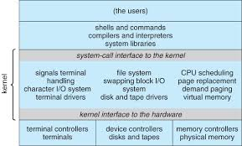
Fig:UNIX system structure
2. Layered Approach

In this approach the OS is distributed into number of layers (levels), each build on top of lower layers. The bottom layer (layer 0) is hardware, the highest layer (layer N) is the user interface. With modularity, layers are selected such that each uses functions and services off only lower layer approach. This system simplifies debugging without the concern of rest of the system.

Once first layer is debugged its functioning can be used while 2nd layer is debugged and so on. If any error found in that layer, it must be on that layer, because the layers below are already debugged.
Each layer is implemented with those operations provided by lower level layers.

The main disadvantage of the approach is it involves careful definition of the system because one layers uses the operations of its lower layer. They tend to be less efficient than other types.

Eg: When a user program executes an I/O operation, it executes a system call that is trapped to I/O layer, which call memory management in turn calls CPU She dulling layer which is then passed to hardware. AT each level parameters need to be modifies and data need to be passes. So it takes longer time to do so.

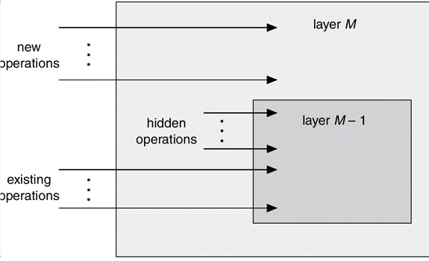
Fig:An Operating system layer

OS/2 layer Approach
The extension of layer approach is OS/2 layer structure. It is a descendant of MS-Dos that adds multitasking and dual mode operation as well as other new features. This approach is designed in more layered approach.in this direct usaer access to low-level facilities is not allowed, providing the os with more control over hardware And more knowledge of which resources each user program is using.

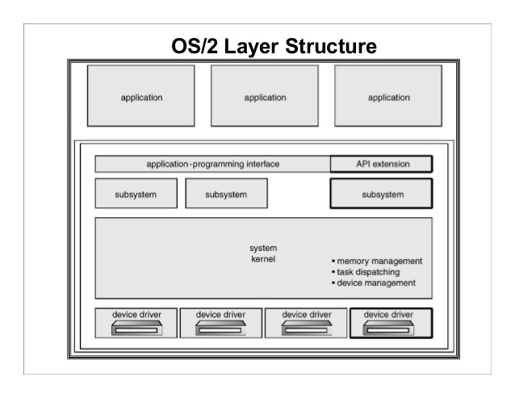
Fig:OS/2 layer structure
Micro kernels:

As the UNIX operating system expanded, the kernel became large and difficult to manage. So they developed Mac-OS that modularized the kernel using the micro kernel approach.It removed all non-essential components from kernel and implemented as system level and user level programs. The result is a small kernel.
The main function of microkernel is to provide a communication facility between client program and various service that are running in user space by using message passing technique. The advantage of this structure is we can add new service to user space and no need to modify kernel space and it is easier to port from one hardware design to another, it is secure and reliable because most services are running at user processes.
Ex: UNIX is a real time operating system based on micro kernel design.

